Guest Family of Wahington DC, & Earlier of North Carolina, USA

By Frank Guest

30th August 2022

Submission to the Guest Family Records Reconciliation Project

(Heritage1066)

Guest Family of Washington DC & earlier of North Carolina USA

Captain Frank B Guest III (1948-) of Washington DC, is a contributor to the Guest family trove and ascending, he has a well recorded family history. He has traced his Gest lineage back to his 2nd great grandparents Francis Guest (1830-1883) and Rachel Ann Guest (1837-1889), nee Whitmore, by record and makes the following chart of his paternal and maternal bloodlines:

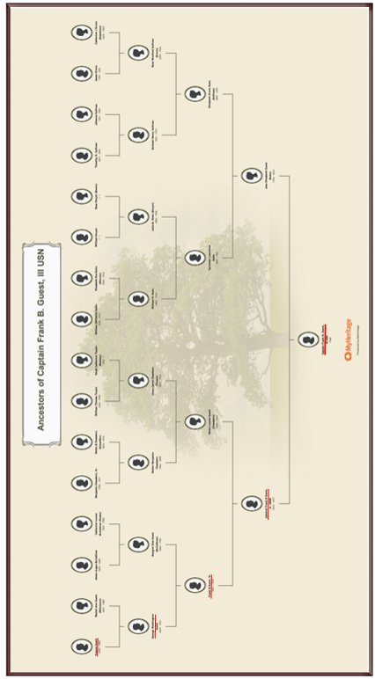
Prima facie, given the evidence available, it is highly probable Francis Guest (1830-1883) is the grandson of Francis Guest (1776-1848) and Anne Guest (1785-1859), nee Hardy.

Francis and Anne married in Tipperary before migrating with children to Canada in 1830/1. They are known to Dr Elliott (2004, p44) study of the Irish Migration to the Canadas along with brother Thomas and his son Thomas junior.

Frank and Anne eldest son Thomas [Henry] Guest (1805-1857) married Mary McRobert (1816-1893) also in Ireland, before migrating with Francis and Anne to Ontario (Irish Records Extraction Database; Record details: Name - Thomas Guest; Sex: Male; Birthplace: of Cloughjordan, County Tipperary, Ireland; Marriage: 15 March 1829; Marriage Place: Modreeny, County Tipperary, Ireland; Spouse: Mary Guest; Miscellaneous: By License Source: Parish Register of Modreeny, Diocese of Killaloe, County Tipperary: Baptisms 1827-1840; Marriages 1827-1845; and Burials 1827, 1882. 25 pages.BR Burials only kept for two years. Record does not state when the parish was closed. The record has been completely extracted for this CD).

A search uncovered a number of males bearing the name Guest who are no doubt closely related to Frank Guest (1948-) 2nd great grandfather Francis Guest (1830-1889).

Rosser, F, 1975, London Township Pioneers, Published by Mika Publishing Company, Belleville, Ontario, 1975), namely (http://my.tbaytel.net/bmartin/london_t.htm):

- Thomas Guest, lot 3, conc.7 (below him, next entered, Joseph Hardy, S1/2 lot 15, conc. 6 (also a further entry for him or namesake, Joseph Hardy, N1/2 lot 1, conc. 5) (Son).
- William Guest, N1/2 lot 2, conc.4. (Probable nephew, son of Thomas Guest, the elder married to Elizabeth Dagg, and their son Thomas Guest junior, who migrated to the USA).
- James Guest, N1/2 lot 4, conc. 12, 1837 (Son).
- John Guest, S1/2 lot 2, conc. 12 (Son).
- Robert Guest, S1/2 lot 4, conc. 12 (Son).

No fewer than seven records of land titleship to males bearing the name McRobert were also registered along with the years the land was granted and there is little doubt one of them, or more, or are related to Thomas Henry Guest (1805-1857) wife, Mary McRobert (Rosser, 1975):

- Andrew McRoberts, lot 9, conc. 13 1826.
- Andrew McRoberts, lot 4, conc. 16.
- John McRoberts, lot 6, conc. 16.
- John McRoberts Jr, lot 8, conc. 16 1834.
- Joseph McRoberts, N1/2 lot 4, conc. 15, 1831.
- Thomas McRoberts, lot 7, conc. 16 1834.
- James McRoberts, N1/2 lot 6, conc. 15; N1/2 lot 7, conc. 15; S1/2 lot 6, conc. 14.
- William McRoberts, S1/2 lot 6 conc. 15.

Given the high occurrence of the Guest family’s custom and practice of migrating in family friendship clusters, and equally or perhaps more so, in strong kinship solidarity clusters including for Guest maternal family members (i.e., Hardy, McRoberts, Armitage, Dagg et al, it is probable the Francis Guest (1830-1889) is a kinsman of Thomas, Joseph, William, James and Robert Guest to whom are probably a combination of brothers and close cousins.
No male bearing the name “Whitmore” can be found in Rosser’s (1975) list of London Pioneers being granted land there, nor for Francis, junior, husband of Rachel suggesting they may have migrated away from Ontario, Canada, perhaps to the USA with Francis, junior’s 2nd cousin Thomas Guest junior.

Informant, Margaret Gaven (Sunday 19th February 2017), of North Vancouver, B.C. Canada, advised that Francis Guest (c1776-1848) and Anne Hardy (c1785-1859) were married in 1804 in Killaloe Diocese, Ireland and that they lived in Shinrone, King's County before moving c1815 to Templemore, County Tipperary.

The family emigrated from there, settling in Birr, Ontario, Canada in 1830. Confirming further that their children were: Thomas Henry Guest; John Guest (1806-1834), unmarried James Guest; Robert Guest; and Francis Guest junior. Further evidence should become available shortly and will be submitted as a supplementary to this family of Guest presently represented by Captain Frank Guest (1948-) of Washington DC, US.

To follow is an idiom of records gathered by the present researcher for Frank and his family.

Francis Guest (1776-) and Anne Hardy’s marriage License (probable 4th great grandparents):

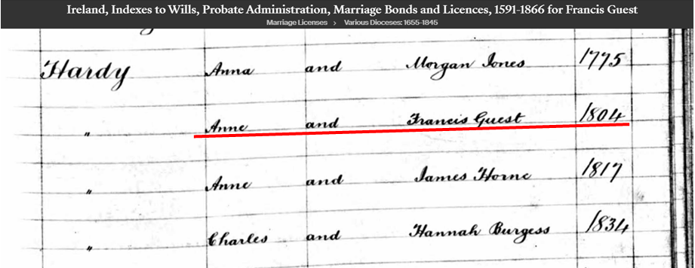

Placement of Francis Guest, junior and wife Rachel in Marylands, USA (Residential directory listing):

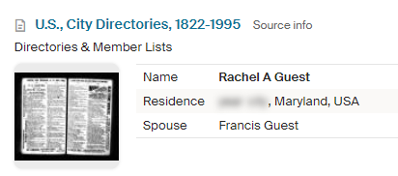
Record of their son, George Washington Guest’s (1858-1931) marriage to Margaret “Maggie” McCathran (1860-1952) in Washington DC:

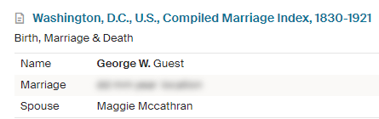

A residential record for them also in Washington, DC:

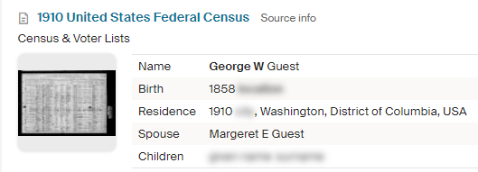

Below is a facsimile of the residential placement record taken also from census and voter lists for Washington DC for their son, Francis Benjamin Guest (1883-1976), senior and his wife Helen “Louisa” Guest (1890-1954), nee Chambers:

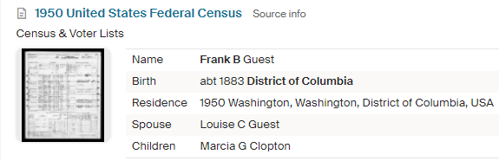

Below is the wonderful portrait of Joan Guest, nee Joan Elizabeth Kuhn (1924-2012), the wife of Admiral Francis Benjamin Guest (1919-1977), junior, of the US Navy. This Francis Benjamin Guest (1919-1977), junior, is the son of forementioned Francis Benjamin Guest (1883-1976), senior and his wife Helen “Louisa” Guest, nee Chambers (1890-1954). Her portrait was published in the newspaper announcing her marriage to Francis, junior:

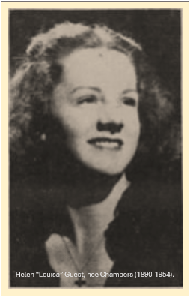

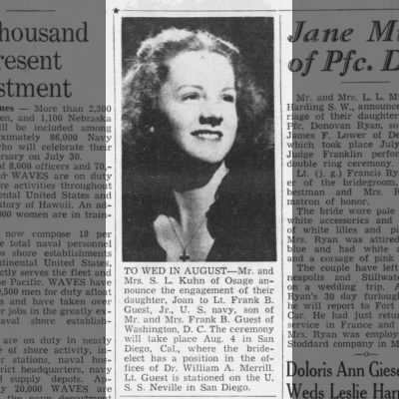
Joan pictured above and husband Admiral Francis Guest (1919-1977 (Francis Benjamin Guest, junior) are the parents of US Naval Captain Frank Benjamin Guest III (1948- , and his siblings. Frank is the present representative of the Guest family branch of Washington DC, USA. His siblings, the children of Joan and Frank are:

- Stephen Guest.
- Joan Guest.
- Marcia Clopton, nee Guest, OSM, formerly of Omaha, Nebraska.
- Captain Frank Benjamin Guest III, based in Norfolk, later returning home to Washington, DC.
- Richard Guest of Washington DC.
- James Guest of Washington DC.
- Robert Guest of New York City.
- Ellen Guest formerly of Boulder, Colorado.

Sourced from the Washington Post, retrieved May 14th 2022, is Admiral Fran (Francis) Guest’s most informative obituary and presents his immediate family and distinguished naval career¹

Rear Adm. Frank B. Guest, Headed Military Sea Lift

Navy Rear Adm. Frank Benjamin Guest Jr., 57, a combat veteran of World War II and the Korean conflict, died of cancer Tuesday at the Navy Regional Medical Center in Philadelphia.

At the time of his health, he headed the Military Sea Lift Command, Atlantic, Headquartered in Bayonne, N. J.

Adm. Guest was on-the-scene commander for the International Naval Review held for the Bicentennial in New York last July 4.

From 1975 through December, 1976, he also had been commandant of the 3d Naval District, comprising New York, Northern New Jersey and Connecticut.

Although he and his family maintained a permanent home in Potomac, he and his wife, Joan Kuhn Guest, and two of their eight children, Stephen and Joan, were living at the Brooklyn Navy Yard at the time of his death.
Born in Washington, Adm. Guest graduated in 1943 from the Georgetown University School of Foreign Service. He was commissioned in the Naval Reserve that year and placed on active duty.

From 1943 to 1946, he served with the pacific Fleet Amphibious Force aboard the attack transport U.S.S. Neville, seeing action in the Marshall and Mariana Island campaigns.

Adm. Guest left active service after the war and returned here, where he was in private business until 1950, when he was recalled to active duty.
He again served aboard an attack transport, the U.S.S. Calvart, and was wounded in Korea.

From the end of 1951 until the beginning of 1954, Adm. Guest was on duty with the Bureau of Naval Personnel in Washington. He later commanded the destroyers U.S.S. Timmerman, U.S.S. Bronson and U.S.S. Hunt, and led Destroyer Squadron 34.

In 1968, he was appointed special assistant for reserve affairs under the assistant secretary of the Navy for manpower and reserve affairs, then special assistant to the commander for Navy recruiting and deputy chief for naval reserve.

Also surviving are his six other children, Sister Marcia, OSM, of Omaha, Neb., Navy Lt. Frank B. III, based in Norfolk, Richard and James, of Washington, Robert, of New York City, and Ellen, of Boulder, Colo; a sister, Marcia Clopton, of Chevy Chase, and two grandchildren.

The family suggests that expressions of sympathy may be in the form of contributions to the American Cancer Society.

Joan’s husband and father of Frank Benjamin Guest III (1948-) is laid to rest at Arlington cemetery with his beloved wife Joan (Arlington County, Virginia, across the Potomac River from Washington, D.C.):

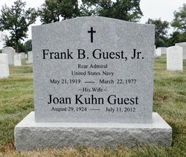

Present representative of the Guest family of Washington DC, Frank Benjamin Guest III (1948-) also had distinguished military career rising to the rank of Captain. Below is a simple record of his naval service when he was aged 27 years, 1st October, 1975):

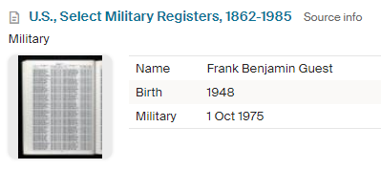

Source: Washington Post: https://www.washingtonpost.com/archive/local/1977/03/25/rear-adm-frank-b-guest-headed-military-sea-lift/94e4d303-1694-4600-bf4d-de978d40192d/

